**IMAGE CAPTION GENERATOR WITH CNN AND LSTM**

**Submitted in the partial fulfilment of the requirements for the award of degree of**

**BACHELOR OF ENGINEERING**

**IN**

**COMPUTER SCIENCE AND ENGINEERING**



**Submitted to Submitted by: 20BCS1868**

**Project teacher**

**Jyoti Bala Mam(E13997)**

**Mentor Signature**

**(Name & E-code)**

**DEPARTMENT OF COMPUTER SCIENCE & ENGINEERING**

**Chandigarh University, Gharuan**

**ABSTRACT**

Image caption generator is a task that involves computer vision and natural language processing concepts to recognize the context of an image and describe them in a natural language like English. In this project, we use CNN and LSTM to identify the caption of the image. As the deep learning techniques are growing, huge datasets and computer power are helpful to build models that can generate captions for an image. This is what we are going to implement in this Python based project where we will use deep learning techniques like CNN and RNN. Image caption generator is a process which involves natural language processing and computer vision concepts to recognize the context of an image and present it in English. In this survey paper, we carefully follow some of the core concepts of image captioning and its common approaches. We discuss Keras library, numpy and Jupyter notebooks for the making of this project. We also discuss about flickr_dataset and CNN used for image classification.

**KEYWORDS**: *generate captions, deep learning techniques, concepts of image captioning.*

**TABLE OF CONTENT**

1. CERTIFICATE
2. ACKNOWLEDGEMENT
3. ABSTRACT
4. CONTENT
5. LIST OF TABLES
6. LIST OF FIGURES
7. ABBREVIATION
8. INTRODUCTION
9. LITERATURE REVIEW
10. SYSTEM DESIGN
11. IMPLEMENTATION
12. CONCLUSION
13. LIMITATION
14. FUTURE SCOPE
15. REFERENCE

**INTRODUCTION**

Every day, we encounter a large number of images from various sources such as the internet, news articles, document diagrams and advertisements. These sources contain images that viewers would have to interpret themselves. Most images do not have a description, but the human can largely understand them without their detailed captions. However, machine needs to interpret some form of image captions if humans need automatic image captions from it.

Image captioning is important for many reasons. Captions for every image on the internet can lead to faster and descriptively accurate images searches and indexing.

Ever since researchers started working on object recognition in images, it became clear that only providing the names of the objects recognized does not make such a good impression as a full human-like description. As long as machines do not think, talk, and behave like humans, natural language descriptions will remain a challenge to be solved.

Image captioning has various applications in various fields such as biomedicine, commerce, web searching and military etc. Social media like Instagram, Facebook etc can generate captions automatically from images.

**IMAGE CAPTIONING**

**Process: -**

Image Captioning is the process of generating textual description of an image. It uses both Natural Language Processing and Computer Vision to generate the captions. Image captioning is a popular research area of Artificial Intelligence (AI) that deals with image understanding and a language description for that image. Image understanding needs to detect and recognize objects. It also needs to understand scene type or location, object properties and their interactions. Generating well-formed sentences requires both syntactic and semantic understanding of the language. Understanding an image largely depends on obtaining image features. For example, they can be used for automatic image indexing. Image indexing is important for Content-Based Image Retrieval (CBIR) and therefore, it can be applied to many areas, including biomedicine, commerce, the military, education, digital libraries, and web searching. Social media platforms such as Facebook and Twitter can directly generate descriptions from images. The descriptions can include where we are (e.g., beach, cafe), what we wear and importantly what we are doing there.

**Techniques: -**

The techniques used for this purpose can be broadly divided into two categories: (1) Traditional machine learning based techniques and (2) Deep machine learning based techniques.

In traditional machine learning, hand crafted features such as Local Binary Patterns (LBP) [107], Scale-Invariant Feature Transform (SIFT) [87], the Histogram of Oriented Gradients (HOG) [27], and a combination of such features are widely used. In these techniques, features are extracted from input data. They are then passed to a classifier such as Support Vector Machines (SVM) [17] in order to classify an object. Since hand crafted features are task specific, extracting features from a large and diverse set of data is not feasible. Moreover, real world data such as images and video are complex and have different semantic interpretations.

On the other hand, in deep machine learning based techniques, features are learned automatically from training data and they can handle a large and diverse set of images and videos. For example, Convolutional Neural Networks (CNN) [79] are widely used for feature learning, and a classifier such as SoftMax is used for classification. CNN is generally followed by Recurrent Neural Networks (RNN) or Long Short-Term Memory Networks (LSTM) in order to generate 10

captions. Deep learning algorithms can handle complexities and challenges of image captioning quite well.

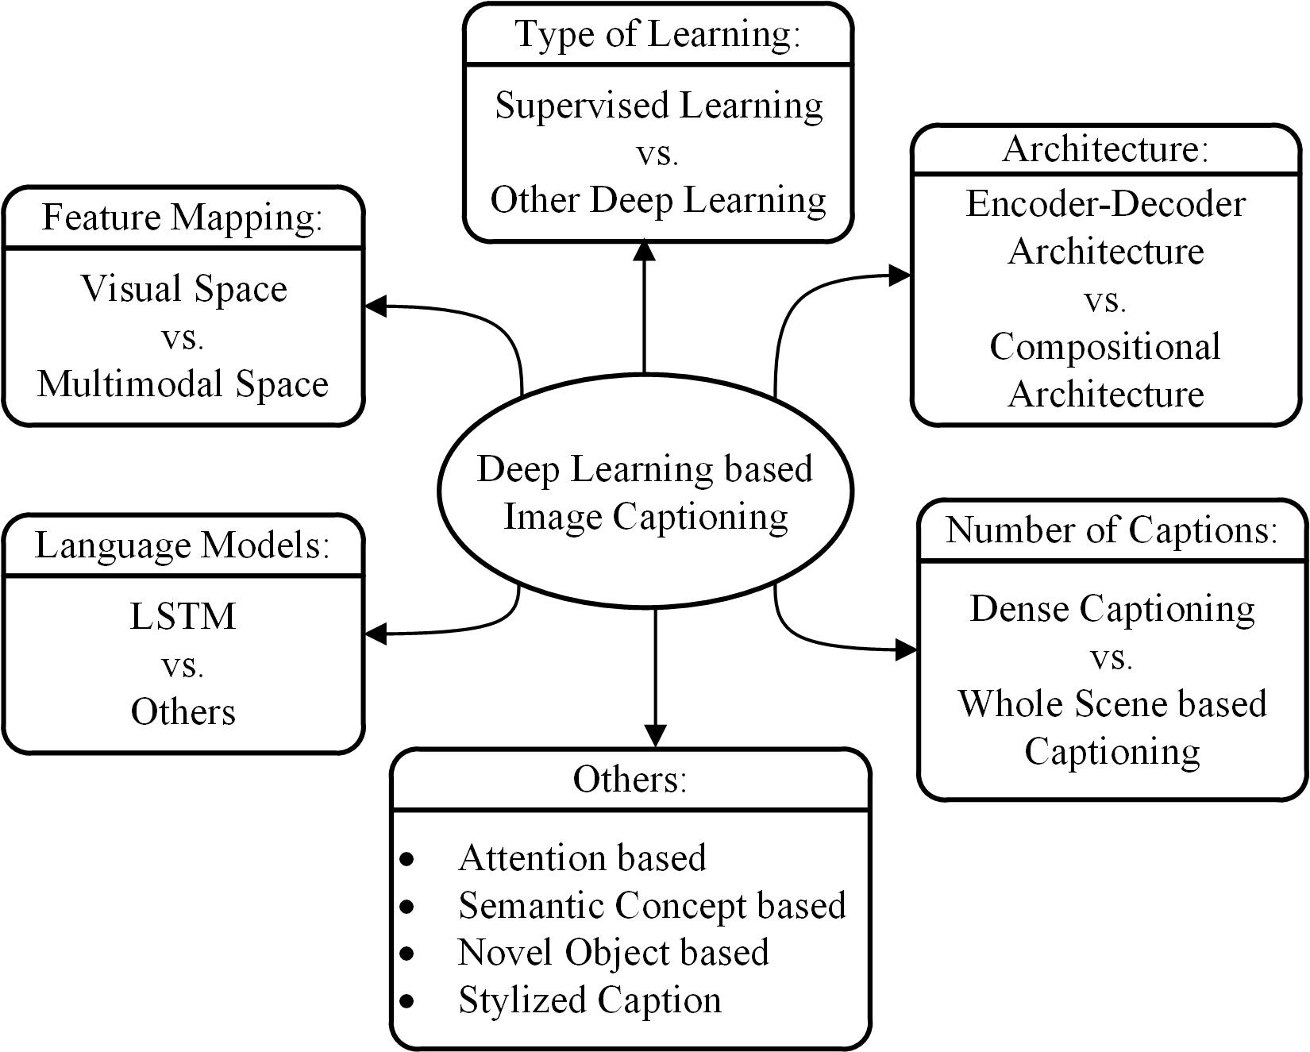

**An overall taxonomy of deep learning-based image captioning**

**LITERATURE REVIEW**

Image captioning has recently gathered a lot of attention specifically in the natural language domain. There is a pressing need for context based natural language description of images, however, this may seem a bit farfetched but recent developments in fields like neural networks, computer vision and natural language processing has paved a way for accurately describing images i.e. representing their visually grounded meaning. We are leveraging state-of-the-art techniques like Convolutional Neural Network (CNN), Recurrent Neural Network (RNN) and appropriate datasets of images and their human perceived description to achieve the same. We demonstrate that our alignment model produces results in retrieval experiments on datasets such as Flicker.

**IMAGE CAPTIONING METHODS**

There are various Image Captioning Techniques some are rarely used in present but it is necessary to take a overview of those technologies before proceeding ahead. The main categories of existing image captioning methods and they include template-based image captioning, retrieval-based image captioning, and novel caption generation. Novel caption generation-based image caption methods mostly use visual space and deep machine learning based techniques. Captions can also be generated from multimodal space. Deep learning-based image captioning methods can also be categorized on learning techniques: Supervised learning, Reinforcement learning, and Unsupervised learning. We group the reinforcement learning and unsupervised learning into Other Deep Learning. Usually captions are generated for a whole scene in the image. However, captions can also be generated for different regions of an image (Dense captioning). Image captioning methods can use either simple Encoder-Decoder architecture or Compositional architecture. There are methods that use attention mechanism, semantic concept, and different styles in image descriptions. Some methods can also generate description for unseen objects. We group them into one category as “Others". Most of the image captioning methods use LSTM as language model. However, there are a number of methods that use other language models such as CNN and RNN. Therefore, we include a language model-based category as “LSTM vs. Others".

**TEMPLATE-BASED APPROACHES**

Template-based approaches have fixed templates with a number of blank slots to generate captions. In these approaches, different objects, attributes, actions are detected first and then the blank spaces in the templates are filled. For example, Farhadi et al. use a triplet of scene

elements to fill the template slots for generating image captions. Li et al. extract the phrases

related to detected objects, attributes and their relationships for this purpose. A Conditional Random Field (CRF) is adopted by Kulkarni et al. to infer the objects, attributes, and prepsitions before filling in the gaps. Template-based methods can generate grammatically correct captions. However, templates are predefined and cannot generate variable-length captions. Moreover, later on, parsing based language models have been introduced in image captioning which are more powerful than fixed template-based methods. Therefore, in this paper, we do not focus on these template-based methods.

**RETRIEVAL-BASED APPROACHES**

Captions can be retrieved from visual space and multimodal space. In retrieval-based approaches, captions are retrieved from a set of existing captions. Retrieval based methods first find the visually similar images with their captions from the training data set. These captions are called candidate captions. The captions for the query image are selected from these captions pool. These methods produce general and syntactically correct captions. However, they cannot generate image specific and semantically correct captions.

**NOVEL CAPTION GENERATION**

Novel image captions are captions that are generated by the model from a combination of the image features and a language model instead of matching to an existing captions. Generating novel image captions solves both of the problems of using existing captions and as such is a much more interesting and useful problem.

Novel captions can be generated from both visual space and multimodal space. A general approach of this category is to analyze the visual content of the image first and then generate image captions from the visual content using a language model These methods can generate new captions for each image that are semantically more accurate than previous approaches.

Most novel caption generation methods use deep machine learning based techniques. Therefore, deep learning based novel image caption generating methods are our main focus in this literature.



**NOVEL CAPTION GENERATION**

**DEEP LEARNING BASED IMAGE CAPTIONING METHODS**

We draw an overall taxonomy in Figure 1 for deep learning-based image captioning methods. We discuss their similarities and dissimilarities by grouping them into visual space vs. multimodal space, dense captioning vs. captions for the whole scene, Supervised learning vs. Other deep learning, Encoder-Decoder architecture vs. Compositional architecture, and one „Others‟ group that contains Attention-Based, Semantic Concept-Based, Stylized captions, and Novel Object-Based captioning. We also create a category named LSTM vs. Others.

A brief overview of the deep learning-based image captioning methods is shown in table. It contains the name of the image captioning methods, the type of deep neural networks used to encode image information, and the language models used in describing the information. In the final column, we give a category label to each captioning technique based on the taxonomy in Figure 1.

**VISUAL SPACE VS. MULTIMODAL SPACE**

Deep learning-based image captioning methods can generate captions from both visual space and

multimodal space. Understandably image captioning datasets have the corresponding captions as text. In the visual space-based methods, the image features and the corresponding captions are

independently passed to the language decoder. In contrast, in a multimodal space case, a shared

multimodal space is learned from the images and the corresponding caption-text. This multimodal representation is then passed to the language decoder.

**VISUAL SPACE**

Bulk of the image captioning methods use visual space for generating captions. In the visual space-based methods, the image features and the corresponding captions are independently passed to the language decoder.

**MULTIMODAL SPACE**

The architecture of a typical multimodal space-based method contains a language Encoder part, a vision part, a multimodal space part, and a language decoder part. A general diagram of multimodal space-based image captioning methods is shown in Figure 2.

The vision part uses a deep convolutional neural network as a feature extractor to extract the

image features. The language encoder part extracts the word features and learns a dense feature

embedding for each word. It then forwards the semantic temporal context to the recurrent layers.

The multimodal space part maps the image features into a common space with the word features.



**A block diagram of multimodal space-based image captioning.**

**SUPERVISED LEARNING VS. OTHER DEEP LEARNING**

In supervised learning, training data come with desired output called label. Unsupervised learning, on the other hand, deals with unla techniques. Reinforcement learning is another type of machine learning approach where the aims of an agent are to discover data and/or labels through exploration and a reward signal. A number of image captioning methods use reinforcement learning and GAN based approaches. These methods sit in the category of “Other Deep Learning". beled data. Generative Adversarial Networks (GANs) are a type of unsupervised learning

**SUPERVISED LEARNING-BASED IMAGE CAPTIONING**

Supervised learning-based networks have successfully been used for many years in image classification, object detection and attribute learning. This progress makes researchers interested in using them in automatic image captioning. In this paper, we have identified a large number of supervised learning-based image captioning methods. We classify them into different categories: (i) Encoder-Decoder Architecture, (ii) Compositional Architecture, (iii) Attention-based, (iv) Semantic concept-based, (v) Stylized captions, (vi) Novel object-based, and (vii) Dense image captioning.

**OTHER DEEP LEARNING-BASED IMAGE CAPTIONING**

In our day-to-day life, data are increasing with unlabelled data because it is often impractical to accurately annotate data. Therefore, recently, researchers are focusing more on reinforcement learning and unsupervised learning-based techniques for image captioning.

**DENSE CAPTIONING VS. CAPTIONS FOR THE WHOLE SCENE**

In dense captioning, captions are generated for each region of the scene. Other methods generate captions for the whole scene.

**DENSE CAPTIONING**

The previous image captioning methods can generate only one caption for the whole image. They use different regions of the image to obtain information of various objects. However, these methods do not generate region wise captions. Johnson et al. [62] proposed an image captioning method called Dense Cap. This method localizes all the salient regions of an image and then it generates descriptions for those regions.

A typical method of this category has the following steps:

(1) Region proposals are generated for the different regions of the given image.

(2) CNN is used to obtain the region-based image features.

(3) The outputs of Step 2 are used by a language model to generate captions for every region.

A block diagram of a typical dense captioning method is given in Figure 4.



**A block diagram of simple Encoder-Decoder architecture-based image captioning.**

**CAPTIONS FOR THE WHOLE SCENE**

Encoder-Decoder architecture, Compositional architecture, attention-based, semantic concept-based, stylized captions, Novel object-based image captioning, and other deep learning networks-based image captioning methods generate single or multiple captions for the whole scene.

**ENCODER-DECODER ARCHITECTURE VS. COMPOSITIONAL ARCHITECTURE**

Some methods use just simple vanilla encoder and decoder to generate captions. However, other methods use multiple networks for it.

**ENCODER-DECODER ARCHITECTURE-BASED IMAGE CAPTIONING**

The neural network-based image captioning methods work as just simple end to end manner. These methods are very similar to the encoder-decoder framework-based neural machine translation [131]. In this network, global image features are extracted from the hidden activations of CNN and then fed them into an LSTM to generate a sequence of words. A typical method of this category has the following general steps:

(1) A vanilla CNN is used to obtain the scene type, to detect the objects and their relationships.

(2) The output of Step 1 is used by a language model to convert them into words, combined

phrases that produce an image captions.

A simple block diagram of this category is given in Figure 5.

**COMPOSITIONAL ARCHITECTURE-BASED IMAGE CAPTIONING**

Compositional architecture-based methods composed of several independent functional building blocks: First, a CNN is used to extract the semantic concepts from the image. Then a language model is used to generate a set of candidate captions. In generating the final caption, these candidate captions are re-ranked using a deep multimodal similarity model.

A typical method of this category maintains the following steps:

(1) Image features are obtained using a CNN.

(2) Visual concepts (e.g. attributes) are obtained from visual features.

(3) Multiple captions are generated by a language model using the information of Step 1 and

Step 2.

(4) The generated captions are re-ranked using a deep multimodal similarity model to select

high quality image captions.

A common block diagram of compositional network-based image captioning methods is given

in Figure 5.



**A block diagram of a compositional network-based captioning**

**LSTM VS. OTHERS**

Image captioning intersects computer vision and natural language processing (NLP) research. NLP tasks, in general, can be formulated as a sequence-to-sequence learning. Several neural language models such as neural probabilistic language model, log-bilinear models, skip-gram models, and recurrent neural networks (RNNs) have been proposed for learning sequence to sequence tasks. RNNs have widely been used in various sequence learning tasks. However, traditional RNNs suffer from vanishing and exploding gradient problems and cannot adequately handle long-term temporal dependencies.

LSTM networks are a type of RNN that has special units in addition to standard units. LSTM units use a memory cell that can maintain information in memory for long periods of time. In recent years, LSTM based models have dominantly been used in sequence-to-sequence learning tasks. Another network, Gated Recurrent Unit (GRU) has a similar structure to LSTM but it does not use separate memory cells and uses fewer gates to control the flow of information.

However, LSTMs ignore the underlying hierarchical structure of a sentence. They also require significant storage due to long-term dependencies through a memory cell. In contrast, CNNs can learn the internal hierarchical structure of the sentences and they are faster in processing than LSTMs. Therefore, recently, convolutional architectures are used in other sequence to sequence tasks, e.g., conditional image generation and machine translation. Inspired by the above success of CNNs in sequence learning tasks, Gu proposed a CNN language model-based image captioning method. This method uses a language-CNN for statistical language modelling. However, the method cannot model the dynamic temporal behaviour of the language model only using a language-CNN. It combines a recurrent network with the language-

CNN to model the temporal dependencies properly.

Aneja proposed a convolutional architecture for the task of image captioning. They use a feed-forward network without any recurrent function. The architecture of the method has four components: (i) input embedding layer (ii) image embedding layer (iii) convolutional module, and (iv) output embedding layer. It also uses an attention mechanism to leverage spatial image features. They evaluate their architecture on the challenging MSCOCO dataset and shows comparable performance to an LSTM based method on standard metrics.

**PROBLEM FORMULATION**

**PROBLEM IDENTIFICATION**

Despite the successes of many systems based on the Recurrent Neural Networks (RNN) many issues remain to be addressed. Among those issues the following two are prominent for most systems.

**1.** The Vanishing Gradient Problem.

**2.** Training an RNN is a very difficult task.

A recurrent neural network is a deep learning algorithm designed to deal with a variety of complex computer tasks such as object classification and speech detection. RNNs are designed to handle a sequence of events that occur in succession, with the understanding of each event based on information from previous events.

Ideally, we would prefer to have the deepest RNNs so they could have a longer memory period and better capabilities. These could be applied for many real-world use-cases such as stock prediction and enhanced speech detection. However, while they sound promising, RNNs are rarely used for real-world scenarios because of the vanishing gradient problem.

**THE VANISHING GRADIENT PROBLEM**

This is one of the most significant challenges for RNNs performance. In practice, the architecture of RNNs restricts its long-term memory capabilities, which are limited to only remembering a few sequences at a time. Consequently, the memory of RNNs is only useful for shorter sequences and short time-periods.

Vanishing Gradient problem arises while training an Artificial Neural Network. This mainly occurs when the network parameters and hyperparameters are not properly set. The vanishing gradient problem restricts the memory capabilities of traditional RNNs—adding too many time-steps increases the chance of facing a gradient problem and losing information when you use backpropagation.

**OBJECTIVE**

**Image Caption Generator with CNN – About the Python based Project**

The objective of our project is to learn the concepts of a CNN and LSTM model and build a working model of Image caption generator by implementing CNN with LSTM.

In this Python project, we will be implementing the caption generator using *CNN (*Convolutional Neural Networks*)*and LSTM (Long short-term memory). The image features will be extracted from Exception which is a CNN model trained on the ImageNet dataset and then we feed the features into the LSTM model which will be responsible for generating the image captions.

Image caption generator is a process of recognizing the context of an image and annotating it with relevant captions using deep learning, and computer vision. It includes the labeling of an image with English keywords with the help of datasets provided during model training. ImageNet dataset is used to train the CNN model called Xception. Xception is responsible for image feature extraction. These extracted features will be fed to the LSTM model which in turn generates the image caption.

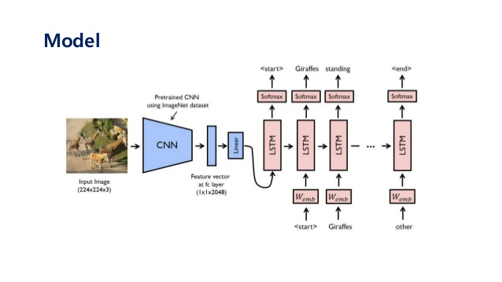

**CONCLUSION:**

The CNN-LSTM model was built on the idea of generating the captions for the input pictures. This model can be used for a variety of applications. In this, we studied about the CNN model, RNN models, LSTM models, and in the end, we validated that the model is generating captions for the input pictures.

**REFERENCES**

[1] Abhaya Agarwal and Alon Lavie. 2008. Meteor, m-bleu and m-ter: Evaluation metrics for high-correlation with human rankings of machine translation output. In Proceedings of the ThirdWorkshop on Statistical Machine Translation.

Association for Computational Linguistics, 115–118.

[2] Ahmet Aker and Robert Gaizauskas. 2010. Generating image descriptions using dependency relational patterns. In

Proceedings of the 48th annual meeting of the association for computational linguistics. Association for Computational

Linguistics, 1250–1258.

[3] Peter Anderson, Basura Fernando, Mark Johnson, and Stephen Gould. 2016. Spice: Semantic propositional image caption evaluation. In European Conference on Computer Vision. Springer, 382–398.

[4] Peter Anderson, Xiaodong He, Chris Buehler, Damien Teney, Mark Johnson, Stephen Gould, and Lei Zhang. 2017. Bottom-up and top-down attention for image captioning and vqa. arXiv preprint arXiv:1707.07998 (2017).

[5] Jyoti Aneja, Aditya Deshpande, and Alexander G Schwing. 2018. Convolutional image captioning. In Proceedings of the IEEE Conference on Computer Vision and Pattern Recognition. 5561–5570.

[6] Lisa Anne Hendricks, Subhashini Venugopalan, Marcus Rohrbach, Raymond Mooney, Kate Saenko, Trevor Darrell, Junhua Mao, Jonathan Huang, Alexander Toshev, Oana Camburu, et al. 2016. Deep compositional captioning: Describing novel object categories without paired training data. In Proceedings of the IEEE Conference on Computer Vision and Pattern Recognition.

[7] Dzmitry Bahdanau, Kyunghyun Cho, and Yoshua Bengio. 2015. Neural machine translation by jointly learning to align and translate. In International Conference on Learning Representations (ICLR).

[8] Shuang Bai and Shan An. 2018. A Survey on Automatic Image Caption Generation. Neurocomputing. ACM Computing Surveys, Vol. 0, No. 0, Article 0. Acceptance Date: October 2018. 0:30 Hossain et al. [9] Satanjeev Banerjee and Alon Lavie. 2005. METEOR: An automatic metric for MT evaluation with improved correlation

with human judgments. In Proceedings of the acl workshop on intrinsic and extrinsic evaluation measures for machine translation and/or summarization, Vol. 29. 65–72.

[10] Samy Bengio, Oriol Vinyals, Navdeep Jaitly, and Noam Shazeer. 2015. Scheduled sampling for sequence prediction with recurrent neural networks. In Advances in Neural Information Processing Systems. 1171–1179.

[11] Yoshua Bengio, Réjean Ducharme, Pascal Vincent, and Christian Jauvin. 2003. A neural probabilistic language model. Journal of machine learning research 3, Feb, 1137–1155.

[12] Adam L Berger, Vincent J Della Pietra, and Stephen A Della Pietra. 1996. A maximum entropy approach to natural language processing. Computational linguistics 22, 1 (1996), 39–71.

[13] Raffaella Bernardi, Ruket Cakici, Desmond Elliott, Aykut Erdem, Erkut Erdem, Nazli Ikizler-Cinbis, Frank Keller, Adrian Muscat, Barbara Plank, et al. 2016. Automatic Description Generation from Images: A Survey of Models, 39 Datasets, and Evaluation Measures. Journal of Artificial Intelligence Research (JAIR) 55, 409–442.

[14] David M Blei, Andrew Y Ng, and Michael I Jordan. 2003. Latent dirichlet allocation. Journal of machine Learning research 3, Jan (2003), 993–1022. [15] Cristian Bodnar. 2018. Text to Image Synthesis Using Generative Adversarial Networks. arXiv preprint

arXiv:1805.00676.

[16] Kurt Bollacker, Colin Evans, Praveen Paritosh, Tim Sturge, and Jamie Taylor. 2008. Freebase: a collaboratively created graph database for structuring human knowledge. In Proceedings of the 2008 ACM SIGMOD international conference on Management of data. AcM, 1247–1250.

[17] Bernhard E Boser, Isabelle M Guyon, and Vladimir N Vapnik. 1992. A training algorithm for optimal margin classifiers. In Proceedings of the fifth annual workshop on Computational learning theory. ACM, 144–152.

[18] Andreas Bulling, Jamie A Ward, Hans Gellersen, and Gerhard Troster. 2011. Eye movement analysis for activity recognition using electrooculography. IEEE transactions on pattern analysis and machine intelligence 33, 4 (2011),

741–753.

[19] Vladimir Bychkovsky, Sylvain Paris, Eric Chan, and Frédo Durand. 2011. Learning photographic global tonal adjustment with a database of input/output image pairs. In Computer Vision and Pattern Recognition (CVPR), 2011